APARTMENT PRE-BOOKING WEBSITE

DESCRIPTION

This is a website that allows client to prebook there desired apartments or villas while sitting at there home. It is a convenient way and easy to use this website. Simple interface and easy to access the information about the villas and apartments.

USED PROGRAMMING LANGUAGES

* HYPER TEXT MARKUP LANGUAGE (HTML)
* CASCADING STYLE SHEET (CSS)
* JAVA SCRIPT
* BOOTSTRAP FOR ICONS

ADVANTAGE OF THIS WEB APPLICATION

* Pre-Book there desired apartments while sitting at there home
* Easy access to information about the villas and apartments
* Simple and interactive interface
* Easy payment method
* More business opportunities
* Exposure to new customers
* Convenient way to book apartments

CODE FOR LOGIN PAGE

<!DOCTYPE html>

<html lang="en">

<head>

<meta charset="UTF-8">

<meta http-equiv="X-UA-Compatible" content="IE=edge">

<meta name="viewport" content="width=device-width, initial-scale=1.0">

<title>SIGN IN</title>

<link rel="stylesheet" href="login.css">

</head>

<body>

<form>

<h1>LOGIN</h1>

<label> USERNAME</label>

<input type="text">

<label>PASSWORD</label>

<input type="password">

<a href="construction.html"><button>LOGIN</a></button>

<a> FORGET PASSWORD?</a>

</form>

CSS FOR LOGIN PAGE

\*{

margin: 0;

padding: 0;

box-sizing: 0;

font-family:'Poppins', sans-serif ;

cursor: pointer;

}

body{

height: 100vh;

width: 100%;

display: flex;

justify-content: center;

align-items:center;

background-image:url('construction2.jpg');

}

form{

width: 25rem;

height: 28rem;

display: flex;

flex-direction: column;

background: rgba(255, 255, 255, 0.06);

box-shadow: 0 8px 32px 0 rgba(31, 38, 135, .37);

border-radius: 30px;

border-left: 1px solid rgba(255, 255, 255, .3);

border-top: 1px solid rgba(255, 255, 255, .3);

}

h1{

font-size: 50px;

text-align: center;

color: white;

text-shadow: 2px 2px 4px rgba(0, 0, 0, .2);

letter-spacing: 3px;

margin-bottom: 5%;

opacity: .7;

}

label{

font-size: 20px;

color: white;

margin-left: 10%;

opacity: .8;

text-shadow:2px 2px 4px rgba(0, 0, 0, .2) ;

}

input{

width: 80%;

margin: 5% auto;

margin-bottom: 8%;

border: none;

outline: none;

background: transparent;

color: white;

border-bottom: 1px solid rgba(255, 255, 255, 0.6) ;

opacity: .8;

}

button{

width: 50%;

margin: 3% auto;

color: white;

font-size: 15px;

opacity: .7;

background: rgba(255, 255, 255, 0.06);

padding: 10px 30px;

border: none;

outline: none;

border-radius: 20px;

text-shadow: 2px 2px 4px rgba(255, 255, 255, 0.2);

box-shadow: 3px 3px 5px rgba(31, 38, 135, .37);

border-left: 1px solid rgba(255, 255, 255, .3);

border-top: 1px solid rgba(255, 255, 255, .3);

}

a{

font-size: 12px;

text-align: center;

color: white;

opacity: .7;

}

JAVA SCRIPT FOR LOGIN PAGE

<script>

function validate() {

var username = document.getElementById("username").value;

var password = document.getElementById("password").value;

if (username === "GIRISH" && password === "GIRISH123") {

alert("Login successful!");

// Redirect to another page here

} else {

alert("Invalid username or password. Please try again.");

}

}

</script>

</body>

</html>

CODE FOR MAIN PAGE

(NAVIGATION BAR)

<!DOCTYPE html>

<html lang="en">

<head>

<meta charset="UTF-8">

<meta http-equiv="X-UA-Compatible" content="IE=edge">

<meta name="viewport" content="width=device-width, initial-scale=1.0">

<link rel="stylesheet" href="css/construction.css">

<title>construction</title>

<script src="https://kit.fontawesome.com/cb35445013.js" crossorigin="anonymous"></script>

<link rel="stylesheet" href="/css/all.min.css">

<link rel="style sheet" href="css/construction.css">

<link rel=" stylesheet" href="css/construction.css">

</head>

<body>

<nav>

<div class="logo">

<ul class="dropdown">

<h1>CONSTRUCTION WEBSITE</h1>

<li><a href="construction.html"><i class="fa-solid fa-house"></i> HOME</a></li>

<li><a href="aboutus.html"><i class="fa-solid fa-users"></i> ABOUT US</a></a></li>

<li><a href="#"><i class="fa-solid fa-phone"></i> CONTACT US</a></li>

<li><a href="#"><i class="fa-solid fa-user-minus"></i> SERVICES</a></li>

</div>

</div></nav>

CSS FOR NAVIGATION BAR

body {

background-image: url('../image/constructionimage2.jpg');

background-repeat: no-repeat;

background-attachment:fixed;

background-size:cover;

}

\*{

margin: 0px;

padding: 0px;

box-sizing: border-box;

}

nav{

width: 100%;

height: 75px;

line-height: 75px;

padding: fixed;

background-image: linear-gradient(black,black);

}

nav ul{

float: right;

}

nav li{

display: inline-block;

list-style: none;

}

nav li a{

font-size:18px;

text-transform:uppercase;

padding:0px 30px;

color:white;

text-decoration: none;

}

\*{

margin: 0;

padding: 0;

box-sizing: border-box;

font-family: 'poppins',sans-serif;

}

h1{

font-size: x-large;

color:#ffa200 ;

text-align: left;

float:left;

}

a:hover{

background-color:yellow;

}

.projects {

list-style-type: none;

display: none;

}

CODE FOR THREE COMBO BOX

<body>

<div class="container">

<div class="combo-box">

<h2 >LOCATION</h2>

<select name="combo1">

<option value="option1"><i class="fa-light fa-location-dot"></i>LOCATION</option>

<option value="option2">CHENNAI</option>

<option value="option3">KUNDRATHUR</option>

<option value="option4">BANGLORE</option>

<option value="option5">HYDERABAD</option>

<option value="option6">DELHI</option>

<option value="option7">MUMBAI</option>

</select>

</div>

<div class="combo-box">

<h2>PROJECT TYPE</h2>

<select name="combo2">

<option value="option1">PROJECT TYPE</option>

<option value="option2">VILLA</option>

<option value="option3">APARTMENT</option>

<option value="option4">PLOTS</option>

</select>

</div>

<div class="combo-box">

<h2>PROJECT STATUS</h2>

<select name="combo3">

<option value="option1">NEW LAUNCH</option>

<option value="option2">PROJECT STATUS</option>

<option value="option3">UNDER CONSTRUCTION</option>

<option value="option4">READY TO OOCUPY</option>

<option value="option5">NEARLY COMPLETION</option>

</select>

</div>

</div>

CSS FOR THREE COMBO BOX

<style>

.container {

display: flex;

flex-direction: row;

justify-content: center;

align-items: center;

height: 100vh;

}

.combo-box {

width: 450px;;

padding: 100px;

border-radius: 5px;

background-color: none;

}

</style>

CODE FOR PRODUCT DISPLAY

<body>

<div class="container1">

<div class="product">

<img src="ap11.png" alt="Product 1">

<h2>product 1</h2>

<p><i class="fa-solid fa-house "></i> Apartments</p>

<p><i class="fa fa-solid fa-map-location-dot "></i> Perungalathur</p>

<p><i class="fa fa-solid fa-bed "></i> 2 & 3 BHK</p>

<p><i class="fa-solid fa-indian-rupee-sign "></i> 43 lakhs onwards</i></p>

<a href="ap1.html"> <button>view more</button></a>

</div>

<div class="product">

<img src="ap2.png" alt="Product 2">

<h2>Product 2</h2>

<p><i class="fa-solid fa-house "></i> Apartments</p>

<p><i class="fa fa-solid fa-map-location-dot "></i> Banglore</p>

<p><i class="fa fa-solid fa-bed "></i> 2 & 3 BHK</p>

<p><i class="fa-solid fa-indian-rupee-sign "></i> 2 crores onwards</i></p>

<a href="ap2.html"><button>view more</button></a>

</div>

<div class="product">

<img src="ap3.png" alt="Product 3">

<h2>Product 3</h2>

<p><i class="fa-solid fa-house "></i> Apartments</p>

<p><i class="fa fa-solid fa-map-location-dot "></i> Chennai</p>

<p><i class="fa fa-solid fa-bed "></i> 2 & 3 BHK</p>

<p><i class="fa-solid fa-indian-rupee-sign "></i> 1.7 crores onwards</i></p>

<a href="ap3.html"><button>view more</button></a>

</div>

<div class="product">

<img src="ap4.png" alt="Product 4">

<h2>Product 4</h2>

<p><i class="fa-solid fa-house "></i> Apartments</p>

<p><i class="fa fa-solid fa-map-location-dot "></i> Coimbatore</p>

<p><i class="fa fa-solid fa-bed "></i> 2 & 3 BHK</p>

<p><i class="fa-solid fa-indian-rupee-sign "></i> 47 lakhs onwards</i></p>

<a href="ap4.html"><button>view more</button></a>

</div>

<div class="product">

<img src="v1.png" alt="Product 4">

<h2>Product 4</h2>

<p><i class="fa-solid fa-house "></i> Villa</p>

<p><i class="fa fa-solid fa-map-location-dot "></i> Kozhikode</p>

<p><i class="fa fa-solid fa-bed "></i> 2 & 3 BHK</p>

<p><i class="fa-solid fa-indian-rupee-sign "></i> 71 lakhs onwards</i></p>

<a href="ap5.html"><button>view more</button></a>

</div>

<div class="product">

<img src="v2.jpg" alt="Product 4">

<h2>Product 4</h2>

<p><i class="fa-solid fa-house "></i> Villa</p>

<p><i class="fa fa-solid fa-map-location-dot "></i> Kundrathur</p>

<p><i class="fa fa-solid fa-bed "></i> 2 & 3 BHK</p>

<p><i class="fa-solid fa-indian-rupee-sign "></i> 55 lakhs onwards</i></p>

<a href="ap6.html"><button >view more</button></a>

</div>

<div class="product">

<img src="v3.jpg" alt="Product 4">

<h2>Product 4</h2>

<p><i class="fa-solid fa-house "></i> Villa</p>

<p><i class="fa fa-solid fa-map-location-dot "></i> Tambaram</p>

<p><i class="fa fa-solid fa-bed "></i> 2 & 3 BHK</p>

<p><i class="fa-solid fa-indian-rupee-sign "></i> 77 lakhs onwards</i></p>

<a href="ap7.html"><button>view more</button></a>

</div>

<div class="product">

<img src="r1.jpg" alt="Product 4">

<h2>Product 4</h2>

<p><i class="fa-solid fa-house "></i> Row House</p>

<p><i class="fa fa-solid fa-map-location-dot "></i> Banglore</p>

<p><i class="fa fa-solid fa-bed "></i> 2 & 3 BHK</p>

<p><i class="fa-solid fa-indian-rupee-sign "></i> 2.5 crores onwards</i></p>

<a href="ap8.html"><button>view more</button></a>

</div>

</div>

</body>

</html>

CSS FOR PRODUCT DISPLAY

<style>

.container1{

position: relative;

display: flex;

flex-wrap: wrap;

justify-content: center;

align-items: center;

padding: 20px;

}

.product {

width: 300px;

margin: 20px;

padding: 10px;

border: 1px solid black;

border-radius: 5px;

background-color: #f1f1f1;

}

.product img {

display: block;

margin: 0 auto;

max-width: 100%;

height: auto;

}

.product h2 {

margin-top: 10px;

font-size: 1.2rem;

text-align: center;

}

.product p {

margin-top: 5px;

font-size: 1rem;

text-align: center;

}

.product button {

display: block;

margin: 10px auto 0;

padding: 10px;

border: none;

border-radius: 5px;

background-color: #3E8E41;

color: white;

font-size: 1rem;

cursor: pointer;

}

.product button:hover {

background-color: #3E8E41;

}

</style>

</head>

CODE FOR APARTMENT 1 DISPLAY

<!DOCTYPE html>

<html lang="en">

<head>

<meta charset="UTF-8">

<meta http-equiv="X-UA-Compatible" content="IE=edge">

<meta name="viewport" content="width=device-width, initial-scale=1.0">

<title>apartment 1</title>

<script src="https://kit.fontawesome.com/cb35445013.js" crossorigin="anonymous"></script>

<style>

.product {

display: flex;

justify-content: center;

align-items: center;

margin-bottom: 20px;

background-color: grey;

}

.product-image {

flex: 1;

margin-right: 20px;

position: relative;

}

.product-image img {

width: 600px;

height: 600px;

margin-bottom: 0px;

}

.product-description {

flex: 2;

display: flex;

flex-direction: column;

height: 600px;

background-color: grey;

margin-left: 50px;

}

.product-description h1{

text-align:center;

}

h1 {

font-size: 1.5rem;

margin-bottom:5px;

color: #ffb300;

font-size: xx-large;

}

.description {

font-size: top ;

margin-bottom: 10px;

}

.add-to-cart {

margin-left: 300px;

background-color: #ffa200;

width: 500px;

color: #fff;

padding: 10px 20px;

border: none;

border-radius: 5px;

cursor: pointer;

transition: all 0.2s ease;

}

.add-to-cart:hover {

transform: scale(1.1);

}

.floor{

margin-left:600px;

background-color:#eceaab;

}

.fram{

margin-left: 600px;

width: 450px;

height: 410px;

}

.des{

background-color:#eceaab;

display: flex;

align-items: center;

margin-left: 0px;

margin-top: 100px;

margin-bottom: 100px;

}

.des p{

margin-left: 300px;

}

.des img{

width: 700px;

height: 600px;

}

ul{

color: #ffffff;

font-size: xx-large;

}

body{

line-height: 1.5;

font-family: 'poppins',sans-serif;

}

\*{

margin:0;

padding:0;

box-sizing: border-box;

}

.container{

max-height: 600px;

margin-left: 100px;

box-sizing: border-box;

max-width: 940px;

}

.row{

display: flex;

width: 1500px;

max-height: 600px;

}

ul{

font-size: 30px;

list-style-type:circle;

}

.footer{

background-color: #24262b;

max-height: 600px;

}

.footer-col{

margin-left: 0px;

margin-right: 100px;

width: 25%;

}

.footer-col h4{

font-size: 18px;

color: #ffffff;

text-transform: capitalize;

margin-bottom: 35px;

font-weight: 500;

position: relative;

}

.footer-col h4::before{

content: '';

position: absolute;

left:0;

bottom: -10px;

background-color: #e91e63;

height: 2px;

box-sizing: border-box;

width: 50px;

}

.footer-col ul li:not(:last-child){

margin-bottom: 10px;

}

.footer-col ul li a{

font-size: 16px;

text-transform: capitalize;

color: #ffffff;

text-decoration: none;

font-weight: 300;

color: #bbbbbb;

display: block;

transition: all 0.3s ease;

}

.footer-col ul li a:hover{

color: #ffffff;

padding-left: 8px;

}

.footer-col .social-links a{

display: inline-block;

height: 40px;

width: 40px;

background-color: rgba(255,255,255,0.2);

margin:0 10px 10px 0;

text-align: center;

line-height: 40px;

border-radius: 50%;

color: #ffffff;

transition: all 0.5s ease;

}

.footer-col .social-links a:hover{

color: #24262b;

background-color: #ffffff;

}

.descr1{

margin-left: 50px;

height: 500px;

}

.descr1 ul{

color: #000000;

font-size: 25px;

list-style-type: circle;

}

.floor1{

background-color:#eceaab;

margin-top: 0px;

}

.floor2{

text-align: center;

}

@media(max-width:767px){

.footer-col{

width: 50%;

margin-bottom: 30px;

}

}

@media(max-width:574px){

.footer-col{

width: 100%;

}

}

</style>

</head>

<body>

<div class="product">

<div class="product-image">

<img src="ap11.png" alt="Product Image">

</div>

<div class="product-description">

<h1>SOUTHBROOKE APARTMENTS</h1>

<ul id="ul1">

<li> PERUNGALATHUR </li>

<li> 43 LAKHS ONWARDS</li>

<li> 2 & 3 BHK APARTMENTS</li>

<li> MODERNISTIC DESIGNES</li>

<li> FUTURISTIC INTERIOR DESIGNES</li>

<li> PRE BOOKING AT JUST FIFTY THOUSAND ONLY</li>

</ul>

<p class="price"></p>

<p class="description"> </p>

<a href="creditcard.html"><button class="add-to-cart">book your apartment</button></a>

</div>

</div>

<div class="floor1">

<div class="floor">

<h1> SOUTHBROOKE HIGHLIGHTS</h1>

</div>

<div class="des">

<img src="ap111.png" alt="des"/>

<div class="descr1">

<ul >

<li>Elegantly designed 316 apartments on 1.76-acres with 77% open space</li>

<li>Superb 2 and 3 BHK apartments built on a B+S+19 storey tower</li>

<li>75+ amenities & features like exclusive 3,000 sft. swimming pool, vibrant kids play zone, senior citizen park, multi play indoor park, etc.</li>

<li>Opulent 7,300 sft. clubhouse with upscale amenities like multi-purpose party hall, mini theatre, gym, indoor games room, etc.</li>

<li>5,500 sft. podium and park with attractions for all five senses</li>

<li>Meticulously planned 7.2 M wide driveway for easy automobile mobility</li>

<li>The community’s 14,000 sft. lush green landscape allows for maximum light and ventilation</li>

<li>100 % Vaastu compliant homes with zero wastage of space</li>

<li>Surrounded by prominent landmarks, schools, colleges, IT/ITES companies & hospitals</li>

</ul>

</div>

</div>

</div>

<div class="floor2">

<h1>FLOOR PLAN</h1>

</div>

<div><iframe class="fram" src="slideshow.html"></iframe>

</div>

<script>

const addToCartBtn = document.querySelector('.add-to-cart');

addToCartBtn.addEventListener('click', addToCart);

function addToCart() {

// Add product to cart logic

alert('congragulations you have selected your apartment !');

}

</script>

<footer class="footer">

<div class="container">

<div class="row">

<div class="footer-col">

<h4>company</h4>

<ul>

<li><a href="#"></a>about us</li>

<li><a href="#"></a>our service</li>

<li><a href="#"></a>privacy</li>

<li><a href="#"></a>affiliate program</li>

</ul>

</div>

<div class="footer-col">

<h4>get help</h4>

<ul>

<li><a href="#"></a>FAQ</li>

<li><a href="#"></a>shipping</li>

<li><a href="#"></a>order status</li>

<li><a href="#"></a>payment option</li>

</ul>

</div>

<div class="footer-col">

<h4>mechandise</h4>

<ul>

<li><a href="#"></a><i class="fa fa-trowel-bricks"></i> bricks</li>

<li><a href="#"></a>cement</li>

<li><a href="#"></a>steel</li>

<li><a href="#"></a>AAC blocks</li>

</ul>

</div>

<div class="footer-col">

<h4>follow us</h4>

<ul>

<li><a href="#"></a> <i class="fa fa-brands fa-facebook-f"></i> facebook</li>

<li><a href="#"></a><i class="fa fa-brands fa-twitter"></i> twitter</li>

<li><a href="#"></a><i class="fa fa-brands fa-instagram"></i> instagram</li>

<li><a href="#"></a><i class="fa fa-brands fa-whatsapp"></i> whatsapp</li>

<li><a href="#"></a><i class="fa fa-brands fa-linkedin"></i> linkedin</li>

</ul>

</div>

</div>

</div>

</footer>

</body>

</html>

CODE FOR APARTMENT 2 DISPLAY

<!DOCTYPE html>

<html lang="en">

<head>

<meta charset="UTF-8">

<meta http-equiv="X-UA-Compatible" content="IE=edge">

<meta name="viewport" content="width=device-width, initial-scale=1.0">

<title>apartment 2</title>

<script src="https://kit.fontawesome.com/cb35445013.js" crossorigin="anonymous"></script>

<style>

.product {

display: flex;

justify-content: center;

align-items: center;

margin-bottom: 20px;

background-color: grey;

}

.product-image {

flex: 1;

margin-right: 20px;

position: relative;

}

.product-image img {

width: 600px;

height: 600px;

margin-bottom: 0px;

}

.product-description {

flex: 2;

display: flex;

flex-direction: column;

height: 600px;

background-color: grey;

margin-left: 50px;

}

.product-description h1{

text-align:center;

}

h1 {

font-size: 1.5rem;

margin-bottom:5px;

color: #ffa200;

font-size: xx-large;

}

.description {

font-size: top ;

margin-bottom: 10px;

}

.add-to-cart {

margin-left: 300px;

background-color: #ffa200;

width: 500px;

color: #fff;

padding: 10px 20px;

border: none;

border-radius: 5px;

cursor: pointer;

transition: all 0.2s ease;

}

.add-to-cart:hover {

transform: scale(1.1);

}

.floor{

margin-left:600px;

background-color:#eceaab;

}

.fram{

margin-left: 600px;

width: 450px;

height: 410px;

}

.des{

background-color:#eceaab;

display: flex;

align-items: center;

margin-left: 0px;

margin-top: 100px;

margin-bottom: 100px;

}

.des p{

margin-left: 300px;

}

.des img{

width: 700px;

height: 600px;

}

ul{

color: #ffffff;

font-size: xx-large;

}

body{

line-height: 1.5;

font-family: 'poppins',sans-serif;

}

\*{

margin:0;

padding:0;

box-sizing: border-box;

}

.container{

max-height: 600px;

margin-left: 100px;

box-sizing: border-box;

max-width: 940px;

}

.row{

display: flex;

width: 1500px;

max-height: 600px;

}

ul{

font-size: 30px;

list-style-type:circle;

}

.footer{

background-color: #24262b;

max-height: 600px;

}

.footer-col{

margin-left: 0px;

margin-right: 100px;

width: 25%;

}

.footer-col h4{

font-size: 18px;

color: #ffffff;

text-transform: capitalize;

margin-bottom: 35px;

font-weight: 500;

position: relative;

}

.footer-col h4::before{

content: '';

position: absolute;

left:0;

bottom: -10px;

background-color: #e91e63;

height: 2px;

box-sizing: border-box;

width: 50px;

}

.footer-col ul li:not(:last-child){

margin-bottom: 10px;

}

.footer-col ul li a{

font-size: 16px;

text-transform: capitalize;

color: #ffffff;

text-decoration: none;

font-weight: 300;

color: #bbbbbb;

display: block;

transition: all 0.3s ease;

}

.footer-col ul li a:hover{

color: #ffffff;

padding-left: 8px;

}

.footer-col .social-links a{

display: inline-block;

height: 40px;

width: 40px;

background-color: rgba(255,255,255,0.2);

margin:0 10px 10px 0;

text-align: center;

line-height: 40px;

border-radius: 50%;

color: #ffffff;

transition: all 0.5s ease;

}

.footer-col .social-links a:hover{

color: #24262b;

background-color: #ffffff;

}

.descr1{

margin-left: 50px;

height: 500px;

background-color: #eceaab;

}

.descr1 ul{

color: #000000;

font-size: 25px;

list-style-type: circle;

}

.floor1{

background-color:#eceaab;

margin-top: 0px;

}

.floor2{

text-align: center;

}

@media(max-width:767px){

.footer-col{

width: 50%;

margin-bottom: 30px;

}

}

@media(max-width:574px){

.footer-col{

width: 100%;

}

}

</style>

</head>

<body>

<div class="product">

<div class="product-image">

<img src="ap22.png" alt="Product Image">

</div>

<div class="product-description">

<h1>ELYSIUM APARTMENTS</h1>

<ul id="ul1">

<li> BANGLORE </li>

<li> 2 CRORES ONWARDS</li>

<li> 2 & 3 BHK APARTMENTS</li>

<li> ELEGANTLY DESIGNED</li>

<li> FUTURISTIC INTERIOR DESIGNES</li>

<li> PRE BOOKING AT JUST SEVENTY THOUSAND ONLY</li>

</ul>

<p class="price"></p>

<p class="description"> </p>

<a href="creditcard.html"><button class="add-to-cart">book your apartment</button></a>

</div>

</div>

<div class="floor1">

<div class="floor">

<h1> ELYSIUM HIGHLIGHTS</h1>

</div>

<div class="des">

<img src="ap222.png" alt="des"/>

<div class="descr1">

<ul >

<li>Elegantly designed 316 apartments on 1.76-acres with 77% open space</li>

<li>Superb 2 and 3 BHK apartments built on a B+S+19 storey tower</li>

<li>75+ amenities & features like exclusive 3,000 sft. swimming pool, vibrant kids play zone, senior citizen park, multi play indoor park, etc.</li>

<li>Opulent 7,300 sft. clubhouse with upscale amenities like multi-purpose party hall, mini theatre, gym, indoor games room, etc.</li>

<li>5,500 sft. podium and park with attractions for all five senses</li>

<li>Meticulously planned 7.2 M wide driveway for easy automobile mobility</li>

<li>The community’s 14,000 sft. lush green landscape allows for maximum light and ventilation</li>

<li>100 % Vaastu compliant homes with zero wastage of space</li>

<li>Surrounded by prominent landmarks, schools, colleges, IT/ITES companies & hospitals</li>

</ul>

</div>

</div>

</div>

<div class="floor2">

<h1>FLOOR PLAN</h1>

</div>

<div><iframe class="fram" src="slideshow.html"></iframe>

</div>

<script>

const addToCartBtn = document.querySelector('.add-to-cart');

addToCartBtn.addEventListener('click', addToCart);

function addToCart() {

// Add product to cart logic

alert('congragulations you have selected your apartment !');

}

</script>

<footer class="footer">

<div class="container">

<div class="row">

<div class="footer-col">

<h4>company</h4>

<ul>

<li><a href="#"></a>about us</li>

<li><a href="#"></a>our service</li>

<li><a href="#"></a>privacy</li>

<li><a href="#"></a>affiliate program</li>

</ul>

</div>

<div class="footer-col">

<h4>get help</h4>

<ul>

<li><a href="#"></a>FAQ</li>

<li><a href="#"></a>shipping</li>

<li><a href="#"></a>order status</li>

<li><a href="#"></a>payment option</li>

</ul>

</div>

<div class="footer-col">

<h4>mechandise</h4>

<ul>

<li><a href="#"></a><i class="fa fa-trowel-bricks"></i> bricks</li>

<li><a href="#"></a>cement</li>

<li><a href="#"></a>steel</li>

<li><a href="#"></a>AAC blocks</li>

</ul>

</div>

<div class="footer-col">

<h4>follow us</h4>

<ul>

<li><a href="#"></a> <i class="fa fa-brands fa-facebook-f"></i> facebook</li>

<li><a href="#"></a><i class="fa fa-brands fa-twitter"></i> twitter</li>

<li><a href="#"></a><i class="fa fa-brands fa-instagram"></i> instagram</li>

<li><a href="#"></a><i class="fa fa-brands fa-whatsapp"></i> whatsapp</li>

<li><a href="#"></a><i class="fa fa-brands fa-linkedin"></i> linkedin</li>

</ul>

</div>

</div>

</div>

</footer>

</body>

</html>

CODE FOR APARTMENT 3 DISPLAY

<!DOCTYPE html>

<html lang="en">

<head>

<meta charset="UTF-8">

<meta http-equiv="X-UA-Compatible" content="IE=edge">

<meta name="viewport" content="width=device-width, initial-scale=1.0">

<title>apartment 3</title>

<script src="https://kit.fontawesome.com/cb35445013.js" crossorigin="anonymous"></script>

<style>

.product {

display: flex;

justify-content: center;

align-items: center;

margin-bottom: 20px;

background-color: grey;

}

.product-image {

flex: 1;

margin-right: 20px;

position: relative;

}

.product-image img {

width: 600px;

height: 600px;

margin-bottom: 0px;

}

.product-description {

flex: 2;

display: flex;

flex-direction: column;

height: 600px;

background-color: grey;

margin-left: 50px;

}

.product-description h1{

text-align:center;

}

h1 {

font-size: 1.5rem;

margin-bottom:5px;

color: #ffa200;

font-size: xx-large;

}

.description {

font-size: top ;

margin-bottom: 10px;

}

.add-to-cart {

margin-left: 300px;

background-color: #ffa200;

width: 500px;

color: #fff;

padding: 10px 20px;

border: none;

border-radius: 5px;

cursor: pointer;

transition: all 0.2s ease;

}

.add-to-cart:hover {

transform: scale(1.1);

}

.floor{

margin-left:600px;

background-color:#eceaab;

}

.fram{

margin-left: 600px;

width: 450px;

height: 410px;

}

.des{

background-color:#eceaab;

display: flex;

align-items: center;

margin-left: 0px;

margin-top: 100px;

margin-bottom: 100px;

}

.des p{

margin-left: 300px;

}

.des img{

width: 700px;

height: 600px;

}

ul{

color: #ffffff;

font-size: xx-large;

}

body{

line-height: 1.5;

font-family: 'poppins',sans-serif;

}

\*{

margin:0;

padding:0;

box-sizing: border-box;

}

.container{

max-height: 600px;

margin-left: 100px;

box-sizing: border-box;

max-width: 940px;

}

.row{

display: flex;

width: 1500px;

max-height: 600px;

}

ul{

font-size: 30px;

list-style-type:circle;

}

.footer{

background-color: #24262b;

max-height: 600px;

}

.footer-col{

margin-left: 0px;

margin-right: 100px;

width: 25%;

}

.footer-col h4{

font-size: 18px;

color: #ffffff;

text-transform: capitalize;

margin-bottom: 35px;

font-weight: 500;

position: relative;

}

.footer-col h4::before{

content: '';

position: absolute;

left:0;

bottom: -10px;

background-color: #e91e63;

height: 2px;

box-sizing: border-box;

width: 50px;

}

.footer-col ul li:not(:last-child){

margin-bottom: 10px;

}

.footer-col ul li a{

font-size: 16px;

text-transform: capitalize;

color: #ffffff;

text-decoration: none;

font-weight: 300;

color: #bbbbbb;

display: block;

transition: all 0.3s ease;

}

.footer-col ul li a:hover{

color: #ffffff;

padding-left: 8px;

}

.footer-col .social-links a{

display: inline-block;

height: 40px;

width: 40px;

background-color: rgba(255,255,255,0.2);

margin:0 10px 10px 0;

text-align: center;

line-height: 40px;

border-radius: 50%;

color: #ffffff;

transition: all 0.5s ease;

}

.footer-col .social-links a:hover{

color: #24262b;

background-color: #ffffff;

}

.descr1{

margin-left: 50px;

height: 500px;

}

.descr1 ul{

color: #000000;

font-size: 25px;

list-style-type: circle;

}

.floor1{

background-color:#eceaab;

margin-top: 0px;

}

.floor2{

text-align: center;

}

@media(max-width:767px){

.footer-col{

width: 50%;

margin-bottom: 30px;

}

}

@media(max-width:574px){

.footer-col{

width: 100%;

}

}

</style>

</head>

<body>

<div class="product">

<div class="product-image">

<img src="ap33.png" alt="Product Image">

</div>

<div class="product-description">

<h1>COSMOS APARTMENTS</h1>

<ul id="ul1">

<li> CHENNAI </li>

<li> 1.7 CRORES ONWARDS</li>

<li> 2 & 3 BHK APARTMENTS</li>

<li> ELEGANTLY DESIGNED</li>

<li> MARVELOUS INTERIOR DESIGNES</li>

<li> PRE BOOKING AT JUST EIGHTY THOUSAND ONLY!</li>

</ul>

<p class="price"></p>

<p class="description"> </p>

<a href="creditcard.html"><button class="add-to-cart">book your apartment</button></a>

</div>

</div>

<div class="floor1">

<div class="floor">

<h1> COSMOS HIGHLIGHTS</h1>

</div>

<div class="des">

<img src="ap333.png" alt="des"/>

<div class="descr1">

<ul >

<li>Elegantly designed 316 apartments on 1.76-acres with 77% open space</li>

<li>Superb 2 and 3 BHK apartments built on a B+S+19 storey tower</li>

<li>75+ amenities & features like exclusive 3,000 sft. swimming pool, vibrant kids play zone, senior citizen park, multi play indoor park, etc.</li>

<li>Opulent 7,300 sft. clubhouse with upscale amenities like multi-purpose party hall, mini theatre, gym, indoor games room, etc.</li>

<li>5,500 sft. podium and park with attractions for all five senses</li>

<li>Meticulously planned 7.2 M wide driveway for easy automobile mobility</li>

<li>The community’s 14,000 sft. lush green landscape allows for maximum light and ventilation</li>

<li>100 % Vaastu compliant homes with zero wastage of space</li>

<li>Surrounded by prominent landmarks, schools, colleges, IT/ITES companies & hospitals</li>

</ul>

</div>

</div>

</div>

<div class="floor2">

<h1>FLOOR PLAN</h1>

</div>

<div><iframe class="fram" src="slideshow.html"></iframe>

</div>

<script>

const addToCartBtn = document.querySelector('.add-to-cart');

addToCartBtn.addEventListener('click', addToCart);

function addToCart() {

// Add product to cart logic

alert('congragulations you have selected your apartment !');

}

</script>

<footer class="footer">

<div class="container">

<div class="row">

<div class="footer-col">

<h4>company</h4>

<ul>

<li><a href="#"></a>about us</li>

<li><a href="#"></a>our service</li>

<li><a href="#"></a>privacy</li>

<li><a href="#"></a>affiliate program</li>

</ul>

</div>

<div class="footer-col">

<h4>get help</h4>

<ul>

<li><a href="#"></a>FAQ</li>

<li><a href="#"></a>shipping</li>

<li><a href="#"></a>order status</li>

<li><a href="#"></a>payment option</li>

</ul>

</div>

<div class="footer-col">

<h4>mechandise</h4>

<ul>

<li><a href="#"></a><i class="fa fa-trowel-bricks"></i> bricks</li>

<li><a href="#"></a>cement</li>

<li><a href="#"></a>steel</li>

<li><a href="#"></a>AAC blocks</li>

</ul>

</div>

<div class="footer-col">

<h4>follow us</h4>

<ul>

<li><a href="#"></a> <i class="fa fa-brands fa-facebook-f"></i> facebook</li>

<li><a href="#"></a><i class="fa fa-brands fa-twitter"></i> twitter</li>

<li><a href="#"></a><i class="fa fa-brands fa-instagram"></i> instagram</li>

<li><a href="#"></a><i class="fa fa-brands fa-whatsapp"></i> whatsapp</li>

<li><a href="#"></a><i class="fa fa-brands fa-linkedin"></i> linkedin</li>

</ul>

</div>

</div>

</div>

</footer>

</body>

</html>

CODE FOR APARTMENT 4 DISPLAY

<!DOCTYPE html>

<html lang="en">

<head>

<meta charset="UTF-8">

<meta http-equiv="X-UA-Compatible" content="IE=edge">

<meta name="viewport" content="width=device-width, initial-scale=1.0">

<title>apartment 4</title>

<script src="https://kit.fontawesome.com/cb35445013.js" crossorigin="anonymous"></script>

<style>

.product {

display: flex;

justify-content: center;

align-items: center;

margin-bottom: 20px;

background-color: grey;

}

.product-image {

flex: 1;

margin-right: 20px;

position: relative;

}

.product-image img {

width: 600px;

height: 600px;

margin-bottom: 0px;

}

.product-description {

flex: 2;

display: flex;

flex-direction: column;

height: 600px;

background-color: grey;

margin-left: 50px;

}

.product-description h1{

text-align:center;

}

h1 {

font-size: 1.5rem;

margin-bottom:5px;

color: #ffa200;

font-size: xx-large;

}

.description {

font-size: top ;

margin-bottom: 10px;

}

.add-to-cart {

margin-left: 300px;

background-color: #ffa200;

width: 500px;

color: #fff;

padding: 10px 20px;

border: none;

border-radius: 5px;

cursor: pointer;

transition: all 0.2s ease;

}

.add-to-cart:hover {

transform: scale(1.1);

}

.floor{

margin-left:600px;

background-color:#eceaab;

}

.fram{

margin-left: 600px;

width: 450px;

height: 410px;

}

.des{

background-color:#eceaab;

display: flex;

align-items: center;

margin-left: 0px;

margin-top: 100px;

margin-bottom: 100px;

}

.des p{

margin-left: 300px;

}

.des img{

width: 700px;

height: 600px;

}

ul{

color: #ffffff;

font-size: xx-large;

}

body{

line-height: 1.5;

font-family: 'poppins',sans-serif;

}

\*{

margin:0;

padding:0;

box-sizing: border-box;

}

.container{

max-height: 600px;

margin-left: 100px;

box-sizing: border-box;

max-width: 940px;

}

.row{

display: flex;

width: 1500px;

max-height: 600px;

}

ul{

font-size: 30px;

list-style-type:circle;

}

.footer{

background-color: #24262b;

max-height: 600px;

}

.footer-col{

margin-left: 0px;

margin-right: 100px;

width: 25%;

}

.footer-col h4{

font-size: 18px;

color: #ffffff;

text-transform: capitalize;

margin-bottom: 35px;

font-weight: 500;

position: relative;

}

.footer-col h4::before{

content: '';

position: absolute;

left:0;

bottom: -10px;

background-color: #e91e63;

height: 2px;

box-sizing: border-box;

width: 50px;

}

.footer-col ul li:not(:last-child){

margin-bottom: 10px;

}

.footer-col ul li a{

font-size: 16px;

text-transform: capitalize;

color: #ffffff;

text-decoration: none;

font-weight: 300;

color: #bbbbbb;

display: block;

transition: all 0.3s ease;

}

.footer-col ul li a:hover{

color: #ffffff;

padding-left: 8px;

}

.footer-col .social-links a{

display: inline-block;

height: 40px;

width: 40px;

background-color: rgba(255,255,255,0.2);

margin:0 10px 10px 0;

text-align: center;

line-height: 40px;

border-radius: 50%;

color: #ffffff;

transition: all 0.5s ease;

}

.footer-col .social-links a:hover{

color: #24262b;

background-color: #ffffff;

}

.descr1{

margin-left: 50px;

height: 500px;

}

.descr1 ul{

color: #000000;

font-size: 25px;

list-style-type: circle;

}

.floor1{

background-color: #eceaab;

margin-top: 0px;

}

.floor2{

text-align: center;

}

@media(max-width:767px){

.footer-col{

width: 50%;

margin-bottom: 30px;

}

}

@media(max-width:574px){

.footer-col{

width: 100%;

}

}

</style>

</head>

<body>

<div class="product">

<div class="product-image">

<img src="ap44.png" alt="Product Image">

</div>

<div class="product-description">

<h1>ATHENS APARTMENTS</h1>

<ul id="ul1">

<li> COIMBATORE </li>

<li> 47 LAKHS CRORES ONWARDS</li>

<li> 2 & 3 BHK APARTMENTS</li>

<li> ELEGANTLY DESIGNED</li>

<li> MARVELOUS INTERIOR DESIGNES</li>

<li> PRE BOOKING AT JUST FOURTY THOUSAND ONLY!</li>

</ul>

<p class="price"></p>

<p class="description"> </p>

<a href="creditcard.html"><button class="add-to-cart">book your apartment</button></a>

</div>

</div>

<div class="floor1">

<div class="floor">

<h1> ATHENS HIGHLIGHTS</h1>

</div>

<div class="des">

<img src="ap444.png" alt="des"/>

<div class="descr1">

<ul >

<li>Elegantly designed 316 apartments on 1.76-acres with 77% open space</li>

<li>Superb 2 and 3 BHK apartments built on a B+S+19 storey tower</li>

<li>75+ amenities & features like exclusive 3,000 sft. swimming pool, vibrant kids play zone, senior citizen park, multi play indoor park, etc.</li>

<li>Opulent 7,300 sft. clubhouse with upscale amenities like multi-purpose party hall, mini theatre, gym, indoor games room, etc.</li>

<li>5,500 sft. podium and park with attractions for all five senses</li>

<li>Meticulously planned 7.2 M wide driveway for easy automobile mobility</li>

<li>The community’s 14,000 sft. lush green landscape allows for maximum light and ventilation</li>

<li>100 % Vaastu compliant homes with zero wastage of space</li>

<li>Surrounded by prominent landmarks, schools, colleges, IT/ITES companies & hospitals</li>

</ul>

</div>

</div>

</div>

<div class="floor2">

<h1>FLOOR PLAN</h1>

</div>

<div><iframe class="fram" src="slideshow.html"></iframe>

</div>

<script>

const addToCartBtn = document.querySelector('.add-to-cart');

addToCartBtn.addEventListener('click', addToCart);

function addToCart() {

// Add product to cart logic

alert('congragulations you have selected your apartment !');

}

</script>

<footer class="footer">

<div class="container">

<div class="row">

<div class="footer-col">

<h4>company</h4>

<ul>

<li><a href="#"></a>about us</li>

<li><a href="#"></a>our service</li>

<li><a href="#"></a>privacy</li>

<li><a href="#"></a>affiliate program</li>

</ul>

</div>

<div class="footer-col">

<h4>get help</h4>

<ul>

<li><a href="#"></a>FAQ</li>

<li><a href="#"></a>shipping</li>

<li><a href="#"></a>order status</li>

<li><a href="#"></a>payment option</li>

</ul>

</div>

<div class="footer-col">

<h4>mechandise</h4>

<ul>

<li><a href="#"></a><i class="fa fa-trowel-bricks"></i> bricks</li>

<li><a href="#"></a>cement</li>

<li><a href="#"></a>steel</li>

<li><a href="#"></a>AAC blocks</li>

</ul>

</div>

<div class="footer-col">

<h4>follow us</h4>

<ul>

<li><a href="#"></a> <i class="fa fa-brands fa-facebook-f"></i> facebook</li>

<li><a href="#"></a><i class="fa fa-brands fa-twitter"></i> twitter</li>

<li><a href="#"></a><i class="fa fa-brands fa-instagram"></i> instagram</li>

<li><a href="#"></a><i class="fa fa-brands fa-whatsapp"></i> whatsapp</li>

<li><a href="#"></a><i class="fa fa-brands fa-linkedin"></i> linkedin</li>

</ul>

</div>

</div>

</div>

</footer>

</body>

</html>

CODE FOR VILLA 1 DISPLAY

<!DOCTYPE html>

<html lang="en">

<head>

<meta charset="UTF-8">

<meta http-equiv="X-UA-Compatible" content="IE=edge">

<meta name="viewport" content="width=device-width, initial-scale=1.0">

<title>villa 1</title>

<script src="https://kit.fontawesome.com/cb35445013.js" crossorigin="anonymous"></script>

<style>

.product {

display: flex;

justify-content: center;

align-items: center;

margin-bottom: 20px;

background-color: grey;

}

.product-image {

flex: 1;

margin-right: 20px;

position: relative;

}

.product-image img {

width: 600px;

height: 600px;

margin-bottom: 0px;

}

.product-description {

flex: 2;

display: flex;

flex-direction: column;

height: 600px;

background-color: grey;

margin-left: 50px;

}

.product-description h1{

text-align:center;

}

h1 {

font-size: 1.5rem;

margin-bottom:5px;

color: #ffa200;

font-size: xx-large;

}

.description {

font-size: top ;

margin-bottom: 10px;

}

.add-to-cart {

margin-left: 300px;

background-color: #ffa200;

width: 500px;

color: #fff;

padding: 10px 20px;

border: none;

border-radius: 5px;

cursor: pointer;

transition: all 0.2s ease;

}

.add-to-cart:hover {

transform: scale(1.1);

}

.floor{

margin-left:600px;

background-color:#eceaab;

}

.fram{

margin-left: 600px;

width: 450px;

height: 410px;

}

.des{

background-color:#eceaab;

display: flex;

align-items: center;

margin-left: 0px;

margin-top: 100px;

margin-bottom: 100px;

}

.des p{

margin-left: 300px;

}

.des img{

width: 700px;

height: 600px;

}

ul{

color: #ffffff;

font-size: xx-large;

}

body{

line-height: 1.5;

font-family: 'poppins',sans-serif;

}

\*{

margin:0;

padding:0;

box-sizing: border-box;

}

.container{

max-height: 600px;

margin-left: 100px;

box-sizing: border-box;

max-width: 940px;

}

.row{

display: flex;

width: 1500px;

max-height: 600px;

}

ul{

font-size: 30px;

list-style-type:circle;

}

.footer{

background-color: #24262b;

max-height: 600px;

}

.footer-col{

margin-left: 0px;

margin-right: 100px;

width: 25%;

}

.footer-col h4{

font-size: 18px;

color: #ffffff;

text-transform: capitalize;

margin-bottom: 35px;

font-weight: 500;

position: relative;

}

.footer-col h4::before{

content: '';

position: absolute;

left:0;

bottom: -10px;

background-color: #e91e63;

height: 2px;

box-sizing: border-box;

width: 50px;

}

.footer-col ul li:not(:last-child){

margin-bottom: 10px;

}

.footer-col ul li a{

font-size: 16px;

text-transform: capitalize;

color: #ffffff;

text-decoration: none;

font-weight: 300;

color: #bbbbbb;

display: block;

transition: all 0.3s ease;

}

.footer-col ul li a:hover{

color: #ffffff;

padding-left: 8px;

}

.footer-col .social-links a{

display: inline-block;

height: 40px;

width: 40px;

background-color: rgba(255,255,255,0.2);

margin:0 10px 10px 0;

text-align: center;

line-height: 40px;

border-radius: 50%;

color: #ffffff;

transition: all 0.5s ease;

}

.footer-col .social-links a:hover{

color: #24262b;

background-color: #ffffff;

}

.descr1{

margin-left: 50px;

height: 500px;

}

.descr1 ul{

color: #000000;

font-size: 25px;

list-style-type: circle;

}

.floor1{

background-color:#eceaab;

margin-top: 0px;

}

.floor2{

text-align: center;

}

@media(max-width:767px){

.footer-col{

width: 50%;

margin-bottom: 30px;

}

}

@media(max-width:574px){

.footer-col{

width: 100%;

}

}

</style>

</head>

<body>

<div class="product">

<div class="product-image">

<img src="v11.png" alt="Product Image">

</div>

<div class="product-description">

<h1>LUXERIA VILLA</h1>

<ul id="ul1">

<li> LOCATED IN KOZHIKODE </li>

<li> 4 BHK VILLAS</li>

<li> 3000sqft BUILT-UP AREA</li>

<li> 71 LAKHS CRORES ONWARDS</li>

<li> MARVELOUS INTERIOR DESIGNES</li>

<li> JUST 5 MIN FROM KOZHIKODE BEACH</li>

<li> PRE BOOKING AT JUST EIGHTY FIVE THOUSAND ONLY!</li>

</ul>

<p class="price"></p>

<p class="description"> </p>

<a href="creditcard.html"><button class="add-to-cart">book your apartment</button></a>

</div>

</div>

<div class="floor1">

<div class="floor">

<h1> LUXERIA HIGHLIGHTS</h1>

</div>

<div class="des">

<img src="v111.png" alt="des"/>

<div class="descr1">

<ul >

<li>243 beautifully crafted 3 &4 BHK villas on 11 acres in 10 minutes from Kozhikode</li>

<li>Premium villa community offering an extensive choice of independent villas & villas.</li>

<li>Villas planned with an exclusive 10 ft wide private backyard for outdoor activities.</li>

<li>60% open space in the community for undisturbed light & ventilation.</li>

<li>Safe & secure community with the best of architecture, amenities & finesse,</li>

<li>Community offers 50 – lifestyle amenities & features like 6,000 sq.fe grand swimming pool, futsal court, amphitheater, interactive gym, children’s play area & many interesting amenities.</li>

<li>A lavish 17,000 sq.ft clubhouse loaded with indoor & terrace amenities</li>

</ul>

</div>

</div>

</div>

<div class="floor2">

<h1>FLOOR PLAN</h1>

</div>

<div><iframe class="fram" src="slideshow.html"></iframe>

</div>

<script>

const addToCartBtn = document.querySelector('.add-to-cart');

addToCartBtn.addEventListener('click', addToCart);

function addToCart() {

// Add product to cart logic

alert('congragulations you have selected your villa !');

}

</script>

<footer class="footer">

<div class="container">

<div class="row">

<div class="footer-col">

<h4>company</h4>

<ul>

<li><a href="#"></a>about us</li>

<li><a href="#"></a>our service</li>

<li><a href="#"></a>privacy</li>

<li><a href="#"></a>affiliate program</li>

</ul>

</div>

<div class="footer-col">

<h4>get help</h4>

<ul>

<li><a href="#"></a>FAQ</li>

<li><a href="#"></a>shipping</li>

<li><a href="#"></a>order status</li>

<li><a href="#"></a>payment option</li>

</ul>

</div>

<div class="footer-col">

<h4>mechandise</h4>

<ul>

<li><a href="#"></a><i class="fa fa-trowel-bricks"></i> bricks</li>

<li><a href="#"></a>cement</li>

<li><a href="#"></a>steel</li>

<li><a href="#"></a>AAC blocks</li>

</ul>

</div>

<div class="footer-col">

<h4>follow us</h4>

<ul>

<li><a href="#"></a> <i class="fa fa-brands fa-facebook-f"></i> facebook</li>

<li><a href="#"></a><i class="fa fa-brands fa-twitter"></i> twitter</li>

<li><a href="#"></a><i class="fa fa-brands fa-instagram"></i> instagram</li>

<li><a href="#"></a><i class="fa fa-brands fa-whatsapp"></i> whatsapp</li>

<li><a href="#"></a><i class="fa fa-brands fa-linkedin"></i> linkedin</li>

</ul>

</div>

</div>

</div>

</footer>

</body>

</html>

CODE FOR VILLA 2 DISPLAY

<!DOCTYPE html>

<html lang="en">

<head>

<meta charset="UTF-8">

<meta http-equiv="X-UA-Compatible" content="IE=edge">

<meta name="viewport" content="width=device-width, initial-scale=1.0">

<title>villa 2</title>

<script src="https://kit.fontawesome.com/cb35445013.js" crossorigin="anonymous"></script>

<style>

.product {

display: flex;

justify-content: center;

align-items: center;

margin-bottom: 20px;

background-color: grey;

}

.product-image {

flex: 1;

margin-right: 20px;

position: relative;

}

.product-image img {

width: 600px;

height: 600px;

margin-bottom: 0px;

}

.product-description {

flex: 2;

display: flex;

flex-direction: column;

height: 600px;

background-color: grey;

margin-left: 50px;

}

.product-description h1{

text-align:center;

}

h1 {

font-size: 1.5rem;

margin-bottom:5px;

color: #ffa200;

font-size: xx-large;

}

.description {

font-size: top ;

margin-bottom: 10px;

}

.add-to-cart {

margin-left: 300px;

background-color: #ffa200;

width: 500px;

color: #fff;

padding: 10px 20px;

border: none;

border-radius: 5px;

cursor: pointer;

transition: all 0.2s ease;

}

.add-to-cart:hover {

transform: scale(1.1);

}

.floor{

margin-left:600px;

background-color:#eceaab;

}

.fram{

margin-left: 600px;

width: 450px;

height: 410px;

}

.des{

background-color:#eceaab;

display: flex;

align-items: center;

margin-left: 0px;

margin-top: 100px;

margin-bottom: 100px;

}

.des p{

margin-left: 300px;

}

.des img{

width: 700px;

height: 600px;

}

ul{

color: #ffffff;

font-size: xx-large;

}

body{

line-height: 1.5;

font-family: 'poppins',sans-serif;

}

\*{

margin:0;

padding:0;

box-sizing: border-box;

}

.container{

max-height: 600px;

margin-left: 100px;

box-sizing: border-box;

max-width: 940px;

}

.row{

display: flex;

width: 1500px;

max-height: 600px;

}

ul{

font-size: 30px;

list-style-type:circle;

}

.footer{

background-color: #24262b;

max-height: 600px;

}

.footer-col{

margin-left: 0px;

margin-right: 100px;

width: 25%;

}

.footer-col h4{

font-size: 18px;

color: #ffffff;

text-transform: capitalize;

margin-bottom: 35px;

font-weight: 500;

position: relative;

}

.footer-col h4::before{

content: '';

position: absolute;

left:0;

bottom: -10px;

background-color: #e91e63;

height: 2px;

box-sizing: border-box;

width: 50px;

}

.footer-col ul li:not(:last-child){

margin-bottom: 10px;

}

.footer-col ul li a{

font-size: 16px;

text-transform: capitalize;

color: #ffffff;

text-decoration: none;

font-weight: 300;

color: #bbbbbb;

display: block;

transition: all 0.3s ease;

}

.footer-col ul li a:hover{

color: #ffffff;

padding-left: 8px;

}

.footer-col .social-links a{

display: inline-block;

height: 40px;

width: 40px;

background-color: rgba(255,255,255,0.2);

margin:0 10px 10px 0;

text-align: center;

line-height: 40px;

border-radius: 50%;

color: #ffffff;

transition: all 0.5s ease;

}

.footer-col .social-links a:hover{

color: #24262b;

background-color: #ffffff;

}

.descr1{

margin-left: 50px;

height: 500px;

}

.descr1 ul{

color: #000000;

font-size: 25px;

list-style-type: circle;

}

.floor1{

background-color:#eceaab;

margin-top: 0px;

}

.floor2{

text-align: center;

}

@media(max-width:767px){

.footer-col{

width: 50%;

margin-bottom: 30px;

}

}

@media(max-width:574px){

.footer-col{

width: 100%;

}

}

</style>

</head>

<body>

<div class="product">

<div class="product-image">

<img src="v22.png" alt="Product Image">

</div>

<div class="product-description">

<h1>AMBERLEY VILLA</h1>

<ul id="ul1">

<li> LOCATED IN KUNDRATHUR </li>

<li> 4 BHK VILLAS</li>

<li> 4000sqft BUILT-UP AREA</li>

<li> 55 LAKHS CRORES ONWARDS</li>

<li> MARVELOUS INTERIOR DESIGNES</li>

<li> JUST 10 MIN FROM PORUR</li>

<li> PRE BOOKING AT JUST SEVENTY THOUSAND ONLY!</li>

</ul>

<p class="price"></p>

<p class="description"> </p>

<a href="creditcard.html"><button class="add-to-cart">book your apartment</button></a>

</div>

</div>

<div class="floor1">

<div class="floor">

<h1> AMBERLEY HIGHLIGHTS</h1>

</div>

<div class="des">

<img src="v222.png" alt="des"/>

<div class="descr1">

<ul >

<li>243 beautifully crafted 3 &4 BHK villas on 11 acres in 10 minutes from Kundrathur</li>

<li>Premium villa community offering an extensive choice of independent villas & villas.</li>

<li>Villas planned with an exclusive 10 ft wide private backyard for outdoor activities.</li>

<li>60% open space in the community for undisturbed light & ventilation.</li>

<li>Safe & secure community with the best of architecture, amenities & finesse,</li>

<li>Community offers 50 – lifestyle amenities & features like 6,000 sq.fe grand swimming pool, futsal court, amphitheater, interactive gym, children’s play area & many interesting amenities.</li>

<li>A lavish 17,000 sq.ft clubhouse loaded with indoor & terrace amenities</li>

</ul>

</div>

</div>

</div>

<div class="floor2">

<h1>FLOOR PLAN</h1>

</div>

<div><iframe class="fram" src="slideshow.html"></iframe>

</div>

<script>

const addToCartBtn = document.querySelector('.add-to-cart');

addToCartBtn.addEventListener('click', addToCart);

function addToCart() {

// Add product to cart logic

alert('congragulations you have selected your villa !');

}

</script>

<footer class="footer">

<div class="container">

<div class="row">

<div class="footer-col">

<h4>company</h4>

<ul>

<li><a href="#"></a>about us</li>

<li><a href="#"></a>our service</li>

<li><a href="#"></a>privacy</li>

<li><a href="#"></a>affiliate program</li>

</ul>

</div>

<div class="footer-col">

<h4>get help</h4>

<ul>

<li><a href="#"></a>FAQ</li>

<li><a href="#"></a>shipping</li>

<li><a href="#"></a>order status</li>

<li><a href="#"></a>payment option</li>

</ul>

</div>

<div class="footer-col">

<h4>mechandise</h4>

<ul>

<li><a href="#"></a><i class="fa fa-trowel-bricks"></i> bricks</li>

<li><a href="#"></a>cement</li>

<li><a href="#"></a>steel</li>

<li><a href="#"></a>AAC blocks</li>

</ul>

</div>

<div class="footer-col">

<h4>follow us</h4>

<ul>

<li><a href="#"></a> <i class="fa fa-brands fa-facebook-f"></i> facebook</li>

<li><a href="#"></a><i class="fa fa-brands fa-twitter"></i> twitter</li>

<li><a href="#"></a><i class="fa fa-brands fa-instagram"></i> instagram</li>

<li><a href="#"></a><i class="fa fa-brands fa-whatsapp"></i> whatsapp</li>

<li><a href="#"></a><i class="fa fa-brands fa-linkedin"></i> linkedin</li>

</ul>

</div>

</div>

</div>

</footer>

</body>

</html>

CODE FOR VILLA 3 DISPLAY

<!DOCTYPE html>

<html lang="en">

<head>

<meta charset="UTF-8">

<meta http-equiv="X-UA-Compatible" content="IE=edge">

<meta name="viewport" content="width=device-width, initial-scale=1.0">

<title>villa 3</title>

<script src="https://kit.fontawesome.com/cb35445013.js" crossorigin="anonymous"></script>

<style>

.product {

display: flex;

justify-content: center;

align-items: center;

margin-bottom: 20px;

background-color: grey;

}

.product-image {

flex: 1;

margin-right: 20px;

position: relative;

}

.product-image img {

width: 600px;

height: 600px;

margin-bottom: 0px;

}

.product-description {

flex: 2;

display: flex;

flex-direction: column;

height: 600px;

background-color: grey;

margin-left: 50px;

}

.product-description h1{

text-align:center;

}

h1 {

font-size: 1.5rem;

margin-bottom:5px;

color:#ffa200;

font-size: xx-large;

}

.description {

font-size: top ;

margin-bottom: 10px;

}

.add-to-cart {

margin-left: 300px;

background-color: #ffa200;

width: 500px;

color: #fff;

padding: 10px 20px;

border: none;

border-radius: 5px;

cursor: pointer;

transition: all 0.2s ease;

}

.add-to-cart:hover {

transform: scale(1.1);

}

.floor{

margin-left:600px;

background-color:#eceaab;

}

.fram{

margin-left: 600px;

width: 450px;

height: 410px;

}

.des{

background-color:#eceaab;

display: flex;

align-items: center;

margin-left: 0px;

margin-top: 100px;

margin-bottom: 100px;

}

.des p{

margin-left: 300px;

}

.des img{

width: 700px;

height: 600px;

}

ul{

color: #ffffff;

font-size: xx-large;

}

body{

line-height: 1.5;

font-family: 'poppins',sans-serif;

}

\*{

margin:0;

padding:0;

box-sizing: border-box;

}

.container{

max-height: 600px;

margin-left: 100px;

box-sizing: border-box;

max-width: 940px;

}

.row{

display: flex;

width: 1500px;

max-height: 600px;

}

ul{

font-size: 30px;

list-style-type:circle;

}

.footer{

background-color: #24262b;

max-height: 600px;

}

.footer-col{

margin-left: 0px;

margin-right: 100px;

width: 25%;

}

.footer-col h4{

font-size: 18px;

color: #ffffff;

text-transform: capitalize;

margin-bottom: 35px;

font-weight: 500;

position: relative;

}

.footer-col h4::before{

content: '';

position: absolute;

left:0;

bottom: -10px;

background-color: #e91e63;

height: 2px;

box-sizing: border-box;

width: 50px;

}

.footer-col ul li:not(:last-child){

margin-bottom: 10px;

}

.footer-col ul li a{

font-size: 16px;

text-transform: capitalize;

color: #ffffff;

text-decoration: none;

font-weight: 300;

color: #bbbbbb;

display: block;

transition: all 0.3s ease;

}

.footer-col ul li a:hover{

color: #ffffff;

padding-left: 8px;

}

.footer-col .social-links a{

display: inline-block;

height: 40px;

width: 40px;

background-color: rgba(255,255,255,0.2);

margin:0 10px 10px 0;

text-align: center;

line-height: 40px;

border-radius: 50%;

color: #ffffff;

transition: all 0.5s ease;

}

.footer-col .social-links a:hover{

color: #24262b;

background-color: #ffffff;

}

.descr1{

margin-left: 50px;

height: 500px;

}

.descr1 ul{

color: #000000;

font-size: 25px;

list-style-type: circle;

}

.floor1{

background-color:#eceaab;

margin-top: 0px;

}

.floor2{

text-align: center;

}

@media(max-width:767px){

.footer-col{

width: 50%;

margin-bottom: 30px;

}

}

@media(max-width:574px){

.footer-col{

width: 100%;

}

}

</style>

</head>

<body>

<div class="product">

<div class="product-image">

<img src="v33.png" alt="Product Image">

</div>

<div class="product-description">

<h1>PLATINUM VILLA</h1>

<ul id="ul1">

<li> LOCATED IN TAMBARAM </li>

<li> 4 BHK VILLAS</li>

<li> 5000sqft BUILT-UP AREA</li>

<li> 77 LAKHS CRORES ONWARDS</li>

<li> ELEGANTLY INTERIOR DESIGNED</li>

<li> JUST 10 MIN FROM TAMBARAM RAILWAY STATION</li>

<li> PRE BOOKING AT JUST SEVENTY THOUSAND ONLY!</li>

</ul>

<p class="price"></p>

<p class="description"> </p>

<a href="creditcard.html"><button class="add-to-cart">book your apartment</button></a>

</div>

</div>

<div class="floor1">

<div class="floor">

<h1> PLATINUM HIGHLIGHTS</h1>

</div>

<div class="des">

<img src="v333.png" alt="des"/>

<div class="descr1">

<ul >

<li>243 beautifully crafted 3 &4 BHK villas on 11 acres in 10 minutes from Tambaram</li>

<li>Premium villa community offering an extensive choice of independent villas & villas.</li>

<li>Villas planned with an exclusive 10 ft wide private backyard for outdoor activities.</li>

<li>60% open space in the community for undisturbed light & ventilation.</li>

<li>Safe & secure community with the best of architecture, amenities & finesse,</li>

<li>Community offers 50 – lifestyle amenities & features like 6,000 sq.fe grand swimming pool, futsal court, amphitheater, interactive gym, children’s play area & many interesting amenities.</li>

<li>A lavish 17,000 sq.ft clubhouse loaded with indoor & terrace amenities</li>

</ul>

</div>

</div>

</div>

<div class="floor2">

<h1>FLOOR PLAN</h1>

</div>

<div><iframe class="fram" src="slideshow.html"></iframe>

</div>

<script>

const addToCartBtn = document.querySelector('.add-to-cart');

addToCartBtn.addEventListener('click', addToCart);

function addToCart() {

// Add product to cart logic

alert('congragulations you have selected your villa !');

}

</script>

<footer class="footer">

<div class="container">

<div class="row">

<div class="footer-col">

<h4>company</h4>

<ul>

<li><a href="#"></a>about us</li>

<li><a href="#"></a>our service</li>

<li><a href="#"></a>privacy</li>

<li><a href="#"></a>affiliate program</li>

</ul>

</div>

<div class="footer-col">

<h4>get help</h4>

<ul>

<li><a href="#"></a>FAQ</li>

<li><a href="#"></a>shipping</li>

<li><a href="#"></a>order status</li>

<li><a href="#"></a>payment option</li>

</ul>

</div>

<div class="footer-col">

<h4>mechandise</h4>

<ul>

<li><a href="#"></a><i class="fa fa-trowel-bricks"></i> bricks</li>

<li><a href="#"></a>cement</li>

<li><a href="#"></a>steel</li>

<li><a href="#"></a>AAC blocks</li>

</ul>

</div>

<div class="footer-col">

<h4>follow us</h4>

<ul>

<li><a href="#"></a> <i class="fa fa-brands fa-facebook-f"></i> facebook</li>

<li><a href="#"></a><i class="fa fa-brands fa-twitter"></i> twitter</li>

<li><a href="#"></a><i class="fa fa-brands fa-instagram"></i> instagram</li>

<li><a href="#"></a><i class="fa fa-brands fa-whatsapp"></i> whatsapp</li>

<li><a href="#"></a><i class="fa fa-brands fa-linkedin"></i> linkedin</li>

</ul>

</div>

</div>

</div>

</footer>

</body>

</html>

CODE FOR ROW HOSUE DISPLAY

<!DOCTYPE html>

<html lang="en">

<head>

<meta charset="UTF-8">

<meta http-equiv="X-UA-Compatible" content="IE=edge">

<meta name="viewport" content="width=device-width, initial-scale=1.0">

<title>row house</title>

<script src="https://kit.fontawesome.com/cb35445013.js" crossorigin="anonymous"></script>

<style>

.product {

display: flex;

justify-content: center;

align-items: center;

margin-bottom: 20px;

background-color: grey;

}

.product-image {

flex: 1;

margin-right: 20px;

position: relative;

}

.product-image img {

width: 600px;

height: 600px;

margin-bottom: 0px;

}

.product-description {

flex: 2;

display: flex;

flex-direction: column;

height: 600px;

background-color: grey;

margin-left: 50px;

}

.product-description h1{

text-align:center;

}

h1 {

font-size: 1.5rem;

margin-bottom:5px;

color: #ffa200;

font-size: xx-large;

}

.description {

font-size: top ;

margin-bottom: 10px;

}

.add-to-cart {

margin-left: 300px;

background-color: #ffa200;

width: 500px;

color: #fff;

padding: 10px 20px;

border: none;

border-radius: 5px;

cursor: pointer;

transition: all 0.2s ease;

}

.add-to-cart:hover {

transform: scale(1.1);

}

.floor{

margin-left:600px;

background-color:#eceaab;

}

.fram{

margin-left: 600px;

width: 450px;

height: 410px;

}

.des{

background-color:#eceaab;

display: flex;

align-items: center;

margin-left: 0px;

margin-top: 100px;

margin-bottom: 100px;

}

.des p{

margin-left: 300px;

}

.des img{

width: 700px;

height: 600px;

}

ul{

color: #ffffff;

font-size: xx-large;

}

body{

line-height: 1.5;

font-family: 'poppins',sans-serif;

}

\*{

margin:0;

padding:0;

box-sizing: border-box;

}

.container{

max-height: 600px;

margin-left: 100px;

box-sizing: border-box;

max-width: 940px;

}

.row{

display: flex;

width: 1500px;

max-height: 600px;

}

ul{

font-size: 30px;

list-style-type:circle;

}

.footer{

background-color: #24262b;

max-height: 600px;

}

.footer-col{

margin-left: 0px;

margin-right: 100px;

width: 25%;

}

.footer-col h4{

font-size: 18px;

color: #ffffff;

text-transform: capitalize;

margin-bottom: 35px;

font-weight: 500;

position: relative;

}

.footer-col h4::before{

content: '';

position: absolute;

left:0;

bottom: -10px;

background-color: #e91e63;

height: 2px;

box-sizing: border-box;

width: 50px;

}

.footer-col ul li:not(:last-child){

margin-bottom: 10px;

}

.footer-col ul li a{

font-size: 16px;

text-transform: capitalize;

color: #ffffff;

text-decoration: none;

font-weight: 300;

color: #bbbbbb;

display: block;

transition: all 0.3s ease;

}

.footer-col ul li a:hover{

color: #ffffff;

padding-left: 8px;

}

.footer-col .social-links a{

display: inline-block;

height: 40px;

width: 40px;

background-color: rgba(255,255,255,0.2);

margin:0 10px 10px 0;

text-align: center;

line-height: 40px;

border-radius: 50%;

color: #ffffff;

transition: all 0.5s ease;

}

.footer-col .social-links a:hover{

color: #24262b;

background-color: #ffffff;

}

.descr1{

margin-left: 50px;

height: 500px;

}

.descr1 ul{

color: #000000;

font-size: 25px;

list-style-type: circle;

}

.floor1{

background-color:#eceaab;

margin-top: 0px;

}

.floor2{

text-align: center;

}

@media(max-width:767px){

.footer-col{

width: 50%;

margin-bottom: 30px;

}

}

@media(max-width:574px){

.footer-col{

width: 100%;

}

}

</style>

</head>

<body>

<div class="product">

<div class="product-image">

<img src="r11.jpg" alt="Product Image">

</div>

<div class="product-description">

<h1>ROYAL ROW HOUSE</h1>

<ul id="ul1">

<li> LOCATED IN BANGLORE </li>

<li> 2 & 3 BHK ROW HOUSE</li>

<li> 2000sqft BUILT-UP AREA</li>

<li> 2.5 LAKHS CRORES ONWARDS</li>

<li> ELEGANTLY INTERIOR DESIGNED</li>

<li> JUST 10 MIN FROM BANGLORE FORT</li>

<li> PRE BOOKING AT JUST EIGHTY FIVE THOUSAND ONLY!</li>

</ul>

<p class="price"></p>

<p class="description"> </p>

<a href="creditcard.html"><button class="add-to-cart">book your apartment</button></a>

</div>

</div>

<div class="floor1">

<div class="floor">

<h1> ROYAL HIGHLIGHTS</h1>

</div>

<div class="des">

<img src="r111.jpg" alt="des"/>

<div class="descr1">

<ul >

<li>243 beautifully crafted 3 &4 BHK villas on 11 acres in 10 minutes from Banglore</li>

<li>Premium row house community offering an extensive choice of independent villas & villas.</li>

<li>row house planned with an exclusive 10 ft wide private backyard for outdoor activities.</li>

<li>60% open space in the community for undisturbed light & ventilation.</li>

<li>Safe & secure community with the best of architecture, amenities & finesse,</li>

<li>Community offers 50 – lifestyle amenities & features like 6,000 sq.fe grand swimming pool, futsal court, amphitheater, interactive gym, children’s play area & many interesting amenities.</li>

<li>A lavish 17,000 sq.ft clubhouse loaded with indoor & terrace amenities</li>

</ul>

</div>

</div>

</div>

<div class="floor2">

<h1>FLOOR PLAN</h1>

</div>

<div><iframe class="fram" src="slideshow.html"></iframe>

</div>

<script>

const addToCartBtn = document.querySelector('.add-to-cart');

addToCartBtn.addEventListener('click', addToCart);

function addToCart() {

// Add product to cart logic

alert('congragulations you have selected your row house !');

}

</script>

<footer class="footer">

<div class="container">

<div class="row">

<div class="footer-col">

<h4>company</h4>

<ul>

<li><a href="#"></a>about us</li>

<li><a href="#"></a>our service</li>

<li><a href="#"></a>privacy</li>

<li><a href="#"></a>affiliate program</li>

</ul>

</div>

<div class="footer-col">

<h4>get help</h4>

<ul>

<li><a href="#"></a>FAQ</li>

<li><a href="#"></a>shipping</li>

<li><a href="#"></a>order status</li>

<li><a href="#"></a>payment option</li>

</ul>

</div>

<div class="footer-col">

<h4>mechandise</h4>

<ul>

<li><a href="#"></a><i class="fa fa-trowel-bricks"></i> bricks</li>

<li><a href="#"></a>cement</li>

<li><a href="#"></a>steel</li>

<li><a href="#"></a>AAC blocks</li>

</ul>

</div>

<div class="footer-col">

<h4>follow us</h4>

<ul>

<li><a href="#"></a> <i class="fa fa-brands fa-facebook-f"></i> facebook</li>

<li><a href="#"></a><i class="fa fa-brands fa-twitter"></i> twitter</li>

<li><a href="#"></a><i class="fa fa-brands fa-instagram"></i> instagram</li>

<li><a href="#"></a><i class="fa fa-brands fa-whatsapp"></i> whatsapp</li>

<li><a href="#"></a><i class="fa fa-brands fa-linkedin"></i> linkedin</li>

</ul>

</div>

</div>

</div>

</footer>

</body>

</html>

CODE FOR CREDIT CARD

<!DOCTYPE html>

<html lang="en">

<head>

<meta charset="UTF-8">

<meta http-equiv="X-UA-Compatible" content="IE=edge">

<meta name="viewport" content="width=device-width, initial-scale=1.0">

<style>

\*{

font-family: 'Poppins', sans-serif;

margin:0; padding:0;

box-sizing: border-box;

outline: none; border: none;

text-decoration: none;

text-transform: uppercase;}

.container{

min-height: 100vh;

background: #eee;

display: flex;

align-items: center;

justify-content: center;

flex-flow: column;

padding-bottom: 60px;}

.container form{

background: #fff;

border-radius: 5px;

box-shadow: 0 10px 15px rgba(0,0,0,.1);

padding: 20px;

width: 600px;

padding-top: 160px;}

.container form .inputBox{

margin-top: 20px;}

.container form .inputBox span{

display: block;

color:#999;

padding-bottom: 5px;}

.container form .inputBox input,

.container form .inputBox select{

width: 100%;

padding: 10px;

border-radius: 10px;

border:1px solid rgba(0,0,0,.3);

color:#444;}

.container form .flexbox{

display: flex;

gap:15px;}

.container form .flexbox .inputBox{

flex:1 1 150px;}

.container form .submit-btn{

width: 100%;

background:linear-gradient(45deg, blueviolet,deeppink);

margin-top: 20px;

padding: 10px;

font-size: 20px;

color:#fff;

border-radius: 10px;

cursor: pointer;

transition: .2s linear;}

.container form .submit-btn:hover{

letter-spacing: 2px;

opacity: .8;}

.container .card-container{

margin-bottom: -150px;

position: relative;

height: 250px;

width: 400px;}

.container .card-container .front{

position: absolute;

height: 100%;

width: 100%;

top: 0; left: 0;

background:linear-gradient(45deg, blueviolet, deeppink);

border-radius: 5px;

backface-visibility: hidden;

box-shadow: 0 15px 25px rgba(0,0,0,.2);

padding:20px;

transform:perspective(1000px) rotateY(0deg);

transition:transform .4s ease-out;}

.container .card-container .front .image{

display: flex;

align-items:center;

justify-content: space-between;

padding-top: 10px;}

.container .card-container .front .image img{

height: 50px;}

.container .card-container .front .card-number-box{

padding:30px 0;

font-size: 22px;

color:#fff;}

.container .card-container .front .flexbox{

display: flex;}

.container .card-container .front .flexbox .box:nth-child(1){

margin-right: auto;}

.container .card-container .front .flexbox .box{

font-size: 15px;

color:#fff;}

.container .card-container .back{

position: absolute;

top:0; left: 0;

height: 100%;

width: 100%;

background:linear-gradient(45deg, blueviolet, deeppink);

border-radius: 5px;

padding: 20px 0;

text-align: right;

backface-visibility: hidden;

box-shadow: 0 15px 25px rgba(0,0,0,.2);

transform:perspective(1000px) rotateY(180deg);

transition:transform .4s ease-out;}

.container .card-container .back .stripe{

background: #000;

width: 100%;

margin: 10px 0;

height: 50px;}

.container .card-container .back .box{

padding: 0 20px;}

.container .card-container .back .box span{

color:#fff;

font-size: 15px;}

.container .card-container .back .box .cvv-box{

height: 50px;

padding: 10px;

margin-top: 5px;

color:#333;

background: #fff;

border-radius: 5px;

width: 100%;}

.container .card-container .back .box img{

margin-top: 30px;

height: 30px;}

</style>

</head>

<body>

<div class="container">

<div class="card-container">

<div class="front">

<div class="image">

<img src="chip.png">

<img src="visa.jpg">

</div>

<div class="card-number-box">\*\*\*\*\*\*\*\*\*\*\*\*\*\*\*\*</div>

<div class="flexbox">

<div class="box">

<span>card holder</span>

<div class="card-holder-name">full name</div>

</div>

<div class="box">

<span>expires</span>

<div class="expiration">

<span class="exp-month">mm</span>

<span class="exp-year">yy</span>

</div>

</div>

</div>

</div>

<div class="back">

<div class="stripe"></div>

<div class="box">

<span>cvv</span>

<div class="cvv-box"></div>

<img src="image/visa.png" alt="">

</div>

</div>

</div>

<form action="payment.html">

<div class="inputBox">

<span>card number</span>

<input type="text" maxlength="16" class="card-number-input">

</div>

<div class="inputBox">

<span>card holder</span>

<input type="text" class="card-holder-input">

</div>

<div class="flexbox">

<div class="inputBox">

<span>expiration mm</span>

<select name="" id="" class="month-input">

<option value="month" selected disabled>month</option>

<option value="01">01</option>

<option value="02">02</option>

<option value="03">03</option>

<option value="04">04</option>

<option value="05">05</option>

<option value="06">06</option>

<option value="07">07</option>

<option value="08">08</option>

<option value="09">09</option>

<option value="10">10</option>

<option value="11">11</option>

<option value="12">12</option>

</select>

</div>

<div class="inputBox">

<span>expiration yy</span>

<select name="" id="" class="year-input">

<option value="year" selected disabled>year</option>

<option value="2021">2021</option>

<option value="2022">2022</option>

<option value="2023">2023</option>

<option value="2024">2024</option>

<option value="2025">2025</option>

<option value="2026">2026</option>

<option value="2027">2027</option>

<option value="2028">2028</option>

<option value="2029">2029</option>

<option value="2030">2030</option>

</select>

</div>

<div class="inputBox">

<span>cvv</span>

<input type="text" maxlength="4" class="cvv-input">

</div>

</div>

<input type="submit" value="submit" class="submit-btn"></input>

</form>

</div>

<script>

document.querySelector('.card-number-input').oninput = () =>{

document.querySelector('.card-number-box').innerText = document.querySelector('.card-number-input').value;}

document.querySelector('.card-holder-input').oninput = () =>{

document.querySelector('.card-holder-name').innerText = document.querySelector('.card-holder-input').value;}

document.querySelector('.month-input').oninput = () =>{

document.querySelector('.exp-month').innerText = document.querySelector('.month-input').value;}

document.querySelector('.year-input').oninput = () =>{

document.querySelector('.exp-year').innerText = document.querySelector('.year-input').value;}

document.querySelector('.cvv-input').onmouseenter = () =>{

document.querySelector('.front').style.transform = 'perspective(1000px) rotateY(-180deg)';

document.querySelector('.back').style.transform = 'perspective(1000px) rotateY(0deg)';}

document.querySelector('.cvv-input').onmouseleave = () =>{

document.querySelector('.front').style.transform = 'perspective(1000px) rotateY(0deg)';

document.querySelector('.back').style.transform = 'perspective(1000px) rotateY(180deg)';}

document.querySelector('.cvv-input').oninput = () =>{

document.querySelector('.cvv-box').innerText = document.querySelector('.cvv-input').value;}

</script>

</body>

</html>

CODE FOR PAYMENT MESSAGE

<!DOCTYPE html>

<html>

<head>

<title>Payment </title>

<script src="https://kit.fontawesome.com/cb35445013.js" crossorigin="anonymous"></script>

<link rel="stylesheet" type="text/css" href="style.css">

<style>

.container {

margin: auto;

width: 50%;

text-align: center;

}

h1 {

color: green;

font-size: 4rem;

margin-top: 2rem;

}

p {

font-size: 1.5rem;

margin-top: 2rem;

}

</style>

</head>

<body>

<div class="container">

<h1>Payment Successful! <i class="fa fa-light fa-circle-check fa-sm" style="color: #37ff00;"></i></i></h1>

<p>Thank you for pre booking your apartment. Your payment of 50000 has been successfully processed.</p>

<p>You will receive an email confirmation </p>

<p>our customer service will contact you shortly</p>

</div>

<script src="script.js"></script>

</body>

</html>

OUTPUT

LOGIN PAGE

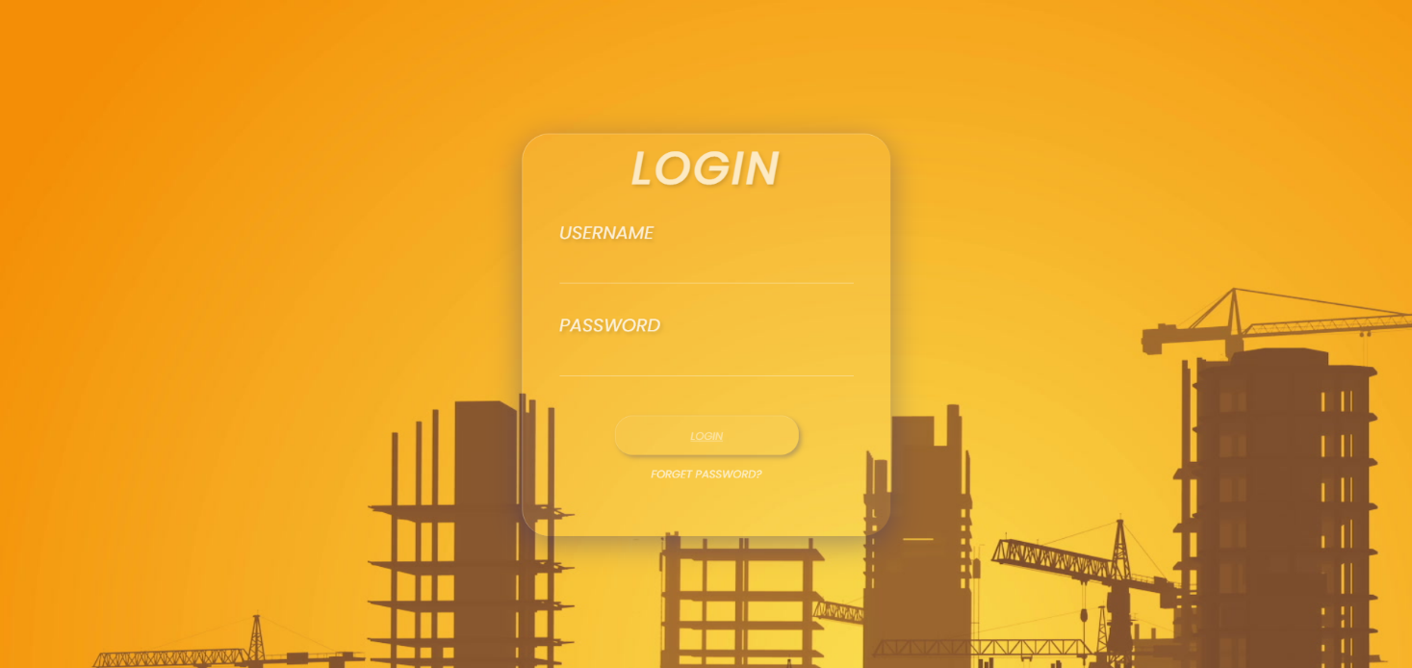

MAIN PAGE

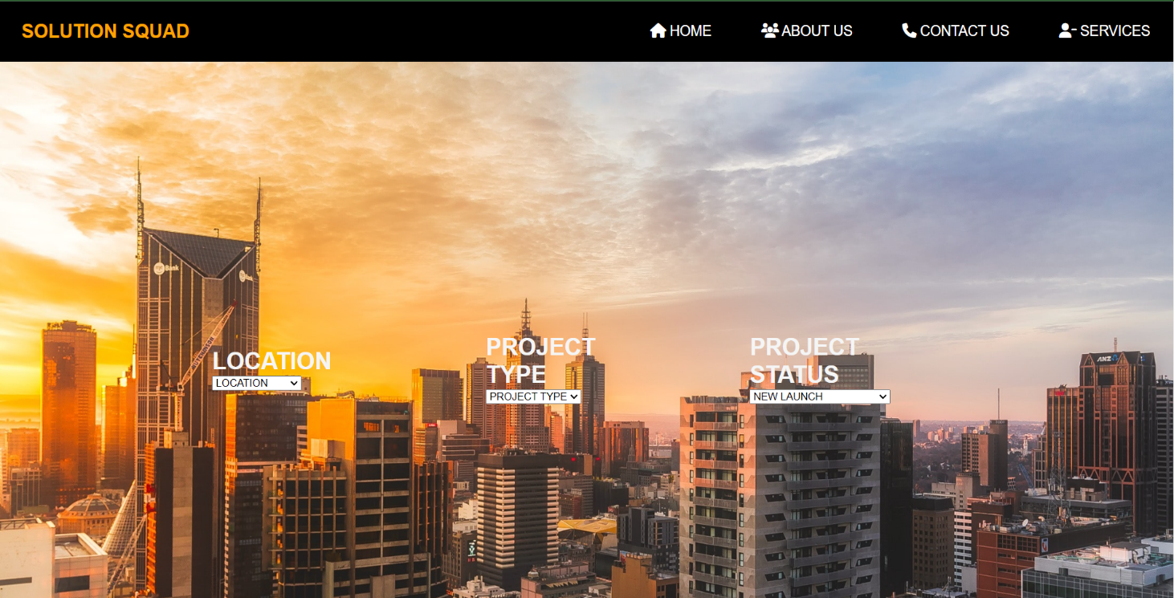

APARTMENTS DISPLAY

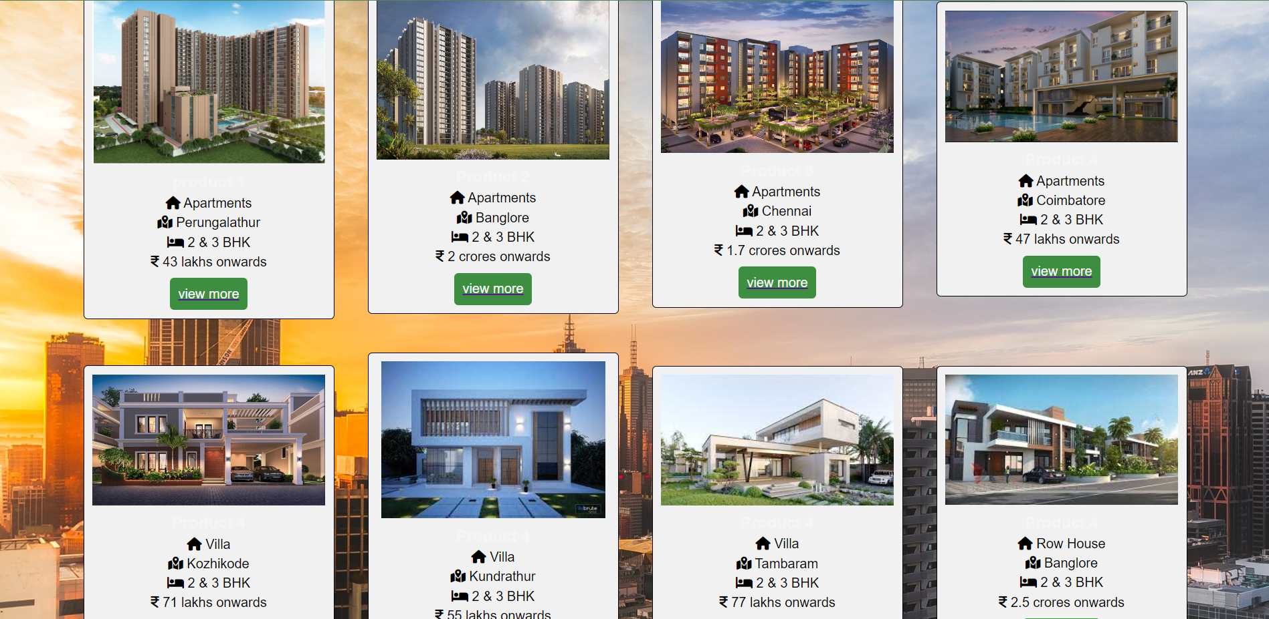

APARTMENT DESCRIPTION PAGE

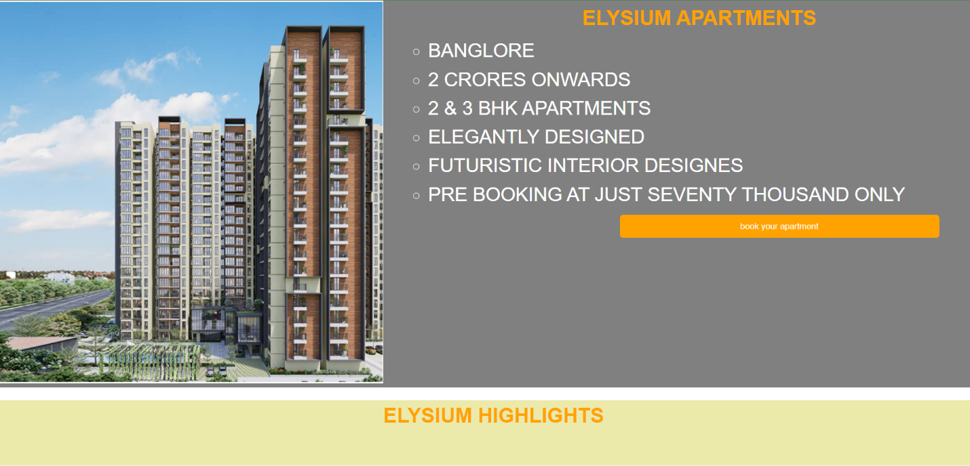

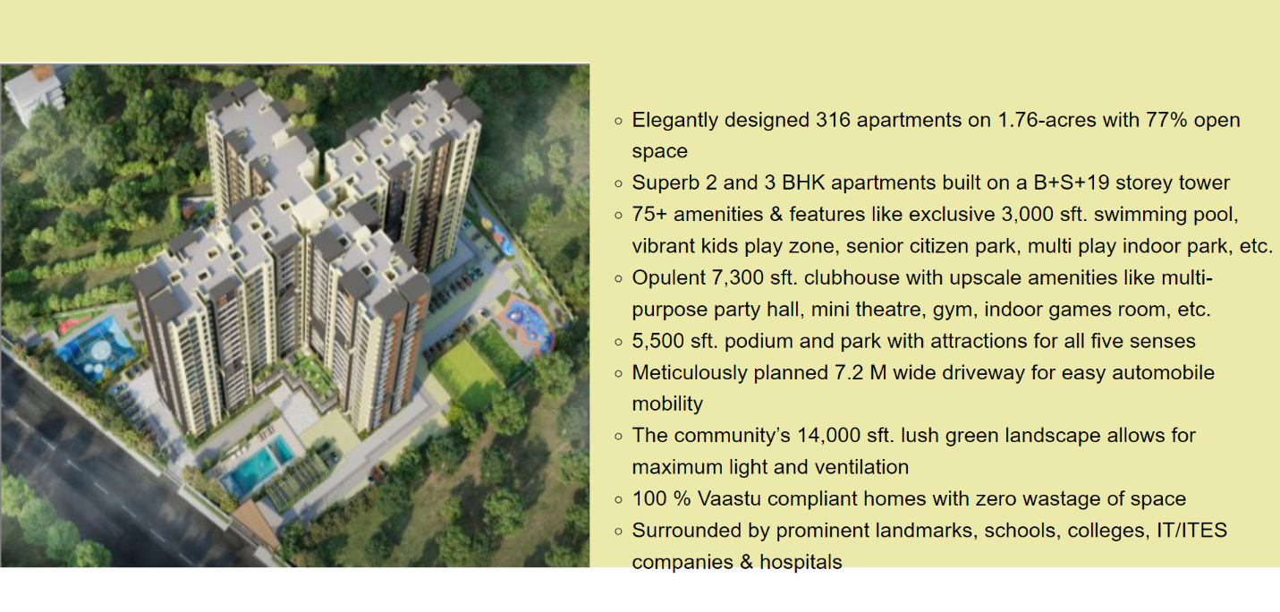

FLOOR PLAN AND FOOTER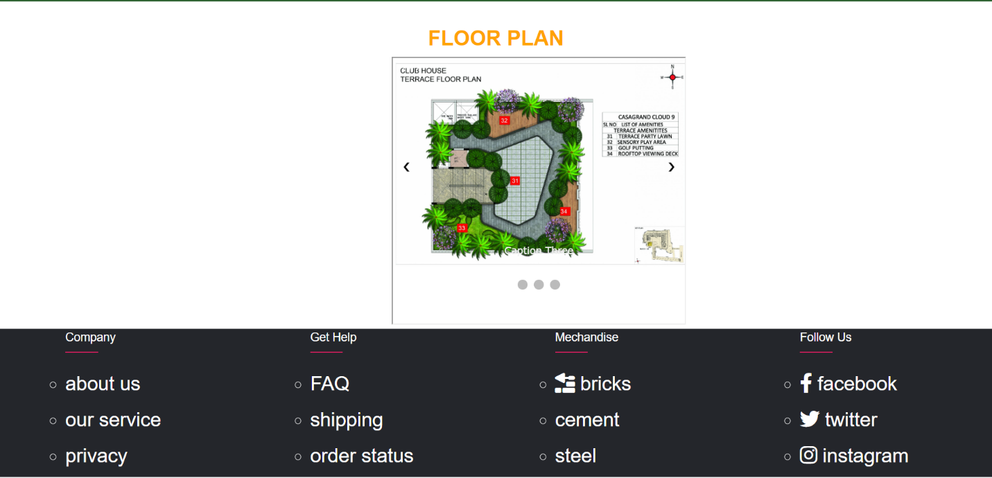

CREDIT CARD   
